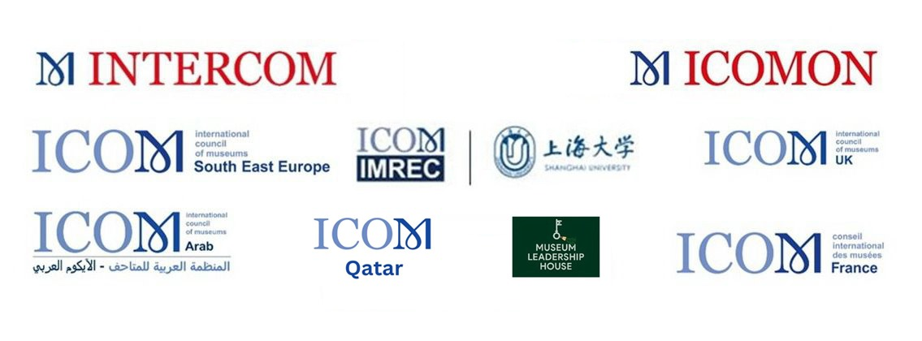

**CALL FOR PAPERS**

ICOM’s International Committee for Museum Management (INTERCOM), along with partner committees ICOMON, ICOM ARAB, ICOM SEE, IMREC, ICOM UK, ICOM France and Museum Leadership House, invites participants of the ICOM Dubai Conference to submit proposals for presentations regarding the two main parts of the INTERCOM sessions.

**ABC SESSIONS**

**Theme 1: 'The Future of Museums in a Rapidly Changing World: the essential role of advocacy to ensure sustainability' (ABC sessions on 12 and 13 November 2025).**

Partners for ABC sessions are INTERCOM, ICOMON, IMREC, ICOM UK, ICOM France and ICOM SEE. Partners will provide panelists and moderators for the sessions.

The main theme will be discussed in three sessions, each covering another specific area:

**1.** **Museum Funding: Emerging Trends and New Futures**

**2.** **Leadership and Strategic Advocacy**

**3. Outsourcing and freelancing**

These three sessions will take place on 12 and 13 November 2025 at the main conference venue. They provide different perspectives that help gain insight in the complexity and importance of advocacy in museum management. From the visible obstacle of funding to the managerial challenges of outsourcing and the importance of advocacy we point to the role of museums in developing ethical management models and leaderships skills to increase the sustainability of their institutions.

**For all three sessions (ABC sessions) we expect flash papers maximum 7 minutes duration.**

**Please find below more detailed expectations for submitting the papers for each ABC session.**

1. Museum Funding: Emerging Trends and New Futures

Museums play a crucial role in fostering well-being, encouraging critical thinking and contributing to social cohesion in a rapidly changing global world. To continue and build on this work, museums require a secure resource base. A recent ICOM-IMREC research project undertaken by the International Research Alliance on Public Funding for Museums (IRAPFM) and initiated by ICOM-IMREC raises the alarm on the world-wide state of public funding for the sector. This global study reveals a pattern of consistent funding decline over the last two decades with no sign raising critical questions about the on-going sustainability of our sector. This session will explore the global situation of public funding, its impact, how museums are responding with new funding models and why advocacy is a strategic necessity for a sustainable future.

• Moderator: Carol Scott (ICOM-IMREC)- 2 mins

• Keynotes: Michele Rivet (IRAPFM), Marek Prokupek (INTERCOM)

***•*** Call for papers related to the synopsis maximum 7 minutes flash presentations:

Papers will be asked to address (a) examples of the impact of government funding being reduced or withdrawn (b) innovative examples of self- generated income (c) examples of new funding models (d) examples of a successful advocacy campaign to raise awareness of the need for on-going government funding.

1. Leadership and Strategic Advocacy

In the light of declining public funding, museum leaders find that their role increasingly requires effective advocacy to leverage new sources of funding and influence decision-making. Among the tools of advocacy are compelling evidence of the beneficial social and economic value of museums and familiarity with existing cultural policy. In addition, however, campaign development, pitching an idea, identifying decision-makers, building a stakeholder base and effective lobbying strategies are also essential. This session will explore values-based advocacy for museum leadership to build sustainable futures.

• Moderator: Hans van Bunte (INTERCOM)

• Keynote speakers: Asma Ibrahim (ICOMON, ICOM Pakistan); Terry Nyambe (ICOM Zambia)

• Call for papers related to the synopsis maximum 7 minutes flash presentations:

Papers will be asked to address (a) examples of a successful advocacy campaign to raise awareness of the need for on-going government funding (b) examples of building stakeholder advocacy groups (c) examples of lobbying campaigns aimed at decision-makers.

1. Outsourcing and Freelancing

While outsourcing has been present in museums for decades in areas such as security, catering, design, etc. and outside experts provide vital services to museums by offering their knowledge, skills and commitment in a wide variety of areas, the growth and type of outsourcing sometimes raises concerns among museum professionals. This might happen when the type of outsourcing significantly influences the leadership of a museum, its daily management, its resource development and its impact on employees – particularly if the purpose of the outsourcing has not been thoughtfully communicated to staff. The results of a recent survey dealing with outsourcing in museums will be presented as a stimulus to generate discussion about how ICOM, as a global museum network, should explore to what extent the outsourcing trend influences the sector and how future developments can be foreseen and managed.

• Moderator: Cristina Vannini (INTERCOM)

• Panelists: Emilie Girard (ICOM France), Kristina Broughton (ICOM UK), Blaise Kilian (ICOMON)

• Call for papers related to the synopsis maximum 7 minutes flash presentations:

Papers will be asked to address (a) examples of problematic outsourcing - what issues they raised and what impacts they had in the short and long-term (b) examples of successfully managing outsourcing to achieve desired results (c) guidance for choosing which type of projects are better outsourced and which are best to keep in-house. We also expect papers on how to work with outsourced consultants and freelancers to secure the best results and how museums leaders do proper briefing, managing expectations, appointing the right person for the job.

**IC DAY - OFF**

**Theme 2: Future scoping: In conversation with young museum leaders of the future (15 November 2025)**

Partner committees: INTERCOM, ICOMON, ICOM ARAB, ICOM SEE, and Museum Leadership House

Venue: EXPO Dubai on 15 November 2025

Time: 9.00 – 15.00

The theme will be discussed in two sessions, each covering another specific area:

1. Existing and emerging museum leaders in the Middle East.
2. How to integrate emerging leaders into ICOM decision-making processes

The sessions will delve into innovative, critical, and forward-looking views on museum leadership.

**We expect presentations up to 10 minutes for both sessions.**

Relevant topics may include studies on new leadership models and essential skills for the 21st century. What competencies will future museum leaders need? How can they be equipped for these challenges, and how will they advocate for the importance of museums in a rapidly changing cultural environment.

The first session focuses on current and emerging museum leaders in the Middle East and invites proposals that explore how regional dynamics affect museum leadership practices. The focus is on both current challenges and creative solutions for the future in the local museum sector. For example, submissions can contextualize museum leadership in the region by analyzing the effects of regional histories, post-colonial influences, and existing local leadership models. In this way, they can explore the balance between protecting cultural heritage and fostering contemporary, inclusive narratives.

Moreover, as part of the research on innovative leadership strategies, we promote research that illustrates how leaders transform museum governance, decision-making and social engagement. A key question in this context could focus on how these leaders modernize their institutions through digital approaches and emerging technologies. Furthermore, we invite submissions that examine the need for educational pathways and leadership development programs for future museum leaders in the Middle East. Other relevant topics that address the challenges and opportunities facing museums include collaborative leadership, funding strategies, and crisis management. Proposals should include significant new information and be backed by empirical research, case studies, or comparative evaluations.

In the second session, which will focus on integrating emerging leaders into ICOM's decision-making, we encourage proposals considering theoretical frameworks and real-world experiences.

Topics of interest include the impact of fresh perspectives on decision-making, ICOM's observations on generational shifts and the evolving dynamics of museum leadership, the challenges of incorporating up-and-coming leaders into an organizational network, bridging generational gaps, ensuring diversity and representation, and fostering future-oriented decision-making and mentorship, among others.

**GENERAL INFROMATION**

It is anticipated that those who submit proposals for this call would register for and attend the ICOM Dubai Conference and cover the associated expenses. All proposals **should be submitted via the official ICOM Dubai platform in English and French and should include the following information:**

1. Name of the person who submits the paper
2. International committee and number of ICOM membership
3. Institution of employment and role in the institution
4. Session and topic for which the presentation is submitted
5. Title of submitted paper presentation
6. Abstract (200 words minimum - 300 words maximum)
7. Keywords (5)
8. Name(s) of Author(s)
9. Contacts with obligatory email address
10. Support equipment required
11. Marking whether the presentation is planned to be onsite
12. All submissions must include a 100‐word bio with a photograph of each presenter.

The proposals will be evaluated by the members of INTERCOM and partner committees. Selected presenters will be contacted after the selection process according to the timetable given by ICOM Dubai. Selected presenters are requested to submit their complete presentations prior to the meeting and by submitting abstracts they agree to record their presentations to make them available for online participants and consent to the publication of their papers in the conference proceedings.

**Submission Deadline & Confirmation Timelines**

**22 June 2025**

Deadline for all Call for Papers submissions

**By 31 July 2025 (the latest)**

All selected speakers will be notified and must confirm or decline their participation before end of July.

**Note:** The Call for Papers period may be subject to adjustment based on unforeseen circumstances.

**Important Notes for Submitters**

1. Please verify that your email address (submitter and presenting author) is correct as it will be used for contacting you after the review process.
2. Abstract submitter and presenter are required to avoid any conflict of interest.
3. Ensure that all co-authors (if any) approve the abstract submission for potential presentation during the conference.
4. Presenters do not have any right to replace their abstract after their abstracts are accepted.
5. Your submission will be reviewed by the relevant International Committee. Please note that the final decision made by these Committees cannot be appealed, dispute, or negotiated.
6. The acceptance of a Call for Papers does not automatically grant conference attendance. All confirmed submitters, authors, and co-authors must register individually and secure their own funding for attendance, unless explicitly supported by one of the conference grant programmes or if the session you are applying to, and/or the relevant International Committee, can provide support.

Your engagement will be the key to success — join us in shaping the future of the museum sector!

**Important:**

You may submit proposals to only one session per time slot—i.e., Session A, Session B, Session C, or ICs Day. Please do not apply to more than one session scheduled at the same time

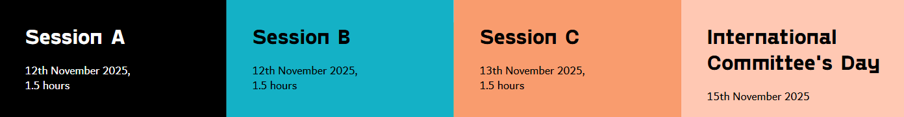

**You are kindly invited to submit your paper via the following link:**

[**https://registrations.dxblive.com/CommunityPortal/Registration/ICOMSURVEY/Abstract.aspx?registrantID=b220f98b-76e9-4d25-93b6-45efad4b39ca**](https://registrations.dxblive.com/CommunityPortal/Registration/ICOMSURVEY/Abstract.aspx?registrantID=b220f98b-76e9-4d25-93b6-45efad4b39ca)

We look forward to receiving your valuable contributions.